OUM

AN.100 Analysis Specification

Universal Assistance S.A.

Modificación servicios de cotización

Req 4673 Nuevo Voucher Digital

Author: Alejandro Ledezma

Creation Date: Oct 20, 2021

Last Updated:

Document Ref:

Version: 1A

1. **Title, Subject, Last Updated Date, Reference Number**, **and** **Version** are marked by a Word Bookmark so that they can be easily reproduced in the header and footer of documents. When you change any of these values, be careful not to accidentally delete the bookmark. **You can make bookmarks visible by selecting Tools->Options…View and checking the Bookmarks option in the Show region.**

**Approvals:**

|  |  |
| --- | --- |
| <Approver 1> |  |
| <Approver 2> |  |

1. To add additional approval lines, press [Tab] from the last cell in the table above.
2. You can delete any elements of this cover page that you do not need for your document.

# Document Control

## Change Record

2

| Date | Author | Version | Change Reference |
| --- | --- | --- | --- |
| 20/09/2021 | Alejandro Ledezma | 1 | No Previous Document |
| 20/01/2022 | Karina Aguilera | 2 | Actualización con últimas definiciones |
|  |  |  |  |
|  |  |  |  |

## Reviewers

| Name | Position |
| --- | --- |
|  |  |
|  |  |
|  |  |
|  |  |

Contents

1 Document Control iii

1.1 Change Record iii

1.2 Reviewers iii

2 Overview 1

2.1 Business Objectives 1

2.2 Major Features 1

2.3 Definitions 1

2.4 Mapeo 5

2.5 Scenarios 5

2.6 Examples 6

2.7 Business Rules 6

2.8 Assumptions 6

3 User Interface Descriptions 7

3.1 Surface Feature Descriptions 7

3.2 User Interface Flow Descriptions 7

4 Data and Behavior Analysis 8

4.1 Data Analysis 8

4.2 Behavior Analysis 8

5 Interface Analysis 9

6 Open and Closed Issues 10

6.1 Open Issues 10

6.2 Closed Issues 10

1. To update the table of contents, put the cursor anywhere in the table and press [F9]. To change the number of levels displayed, select the menu option Insert‑>Index and Tables, make sure the Table of Contents tab is active, and change the Number of Levels to a new value.

# Overview

1. The intent is to remove ambiguity from requirements as specified in the Use Case Package. Reference the **Package Diagram** within the Architecture Description (RD.130) to identify the package for which this Analysis Specification applies and the Use Cases that the package contains,

Este documento detalla la necesidad de realizar el nuevo diseño del voucher digital, en esta etapa se realizará una nueva versión del pdf, que incluirá el rediseño del voucher.

## Business Objectives

Realizar el diseño del nuevo pdf del voucher donde se reemplazará el anterior por el nuevo que incluirá los cambios estéticos necesarios para tener un voucher actualizado

1. This section describes the mapping between this package or use case and the business requirements that have been identified in RD.001 Business and System Objectives. Only list objectives that are impacted by this use case or Use Case package.

## Major Features

1. This section includes the Use Case Description headers from the RA.023 Use Case Model. This includes the Use Case Name and the Brief description.

La solución consiste en realizar el rediseño del voucher en formato pdf, en versión Español-Inglés e Inglés. En el documento se especificarán los cambios y se adjuntarán los documentos en formato Word para la configuración en ambos idiomas.

## Definitions

**Bloque Azul**

En la primera página se mostrará la siguiente información:

1. Nombre y apellido del pasajero titular
2. Tipo y nro de Documento
3. Nro Voucher
4. Fecha de Vigencia y Fecha Final
5. Nombre del Producto (Denominación)
6. Destino (Usar RateState)
7. Precio
   1. Dependiendo del tipo de venta del voucher donde si es anual con renovación mostrará el precio de lista sino el precio de emisión. Para Retail variable según indica la agencia si imprime o no tarifa. Sin valor no se muestra el campo.
   2. Para Retail tener en cuenta la definición del Producto

7.Emisor: Organización emisora (Cuando el canal es distinto a “Direct” se mostrará el campo Emisor).

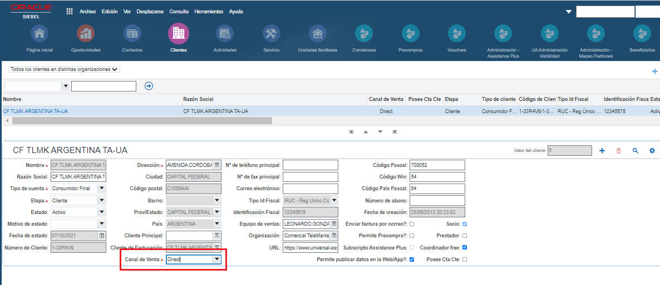

8.Pasajeros

Se mostrará la Cantidad de pasajeros expresado en números.

9.Acompañantes

Se mostrarán el Nombre y apellido, tipo y número de documento de los acompañantes excluyendo al titular, en caso de haber más de uno se agregarán los acompañantes debajo, si es sólo un pasajero no se mostrará la etiqueta de acompañantes.

10.Logo

Se comenzará a tomar el logo de la definición del Cliente, ya no más desde el producto.

Se definirá como logo genérico el de la marca UA y si el cliente tiene definido un logo, se tomará el definido en el Cliente. Se definirá mediante una nueva LOV “**UA_LOGO**” ( se puede usar como referencia la LOV **UA_LOGO_PROD** que actualmente se utiliza para definir el logo a nivel producto).

|  |  |  |
| --- | --- | --- |
| Cliente | Logo (LOV) | Logo (archivo) |
| Genérico | Universal Assistance | logo.png |
| VOLALA | Volala | Logo-volala.png |
| CF RETAIL AEREOS | Flybondi | logo-flybondi.png |
| BCI SEGUROS | BCI | logo-bci.png |
| SURA | Sura | logo-sura.png |
| GRANCALL S.A.S. | AsisTravel | logo-assisttravel.png |
| TRAVEL SAFE - HUMANO | Travel Safe | logo-travelsafe.png |
| METLIFE - BANCO ITAU | MetLife | logo-metlife.png |
| - | Safest | logo-safest.png |
| - | PortoSeguro | logos-portoseguro.png |
| CF TLMK ARGENTINA SANTANDER | Santander | logo-santander.png |
| COCHA | Cocha | logo-cocha.png |

Para esto es necesario crear una nueva columna en el cliente para indicar qué logo utilizará cada cliente.

Agregar un nuevo campo: “Logo” en la Solapa: “Mas Información” de la vista de administración de clientes (Account Detail View).

Quedando el nuevo campo: “Logo” de la siguiente manera en la solapa “Mas Información”:

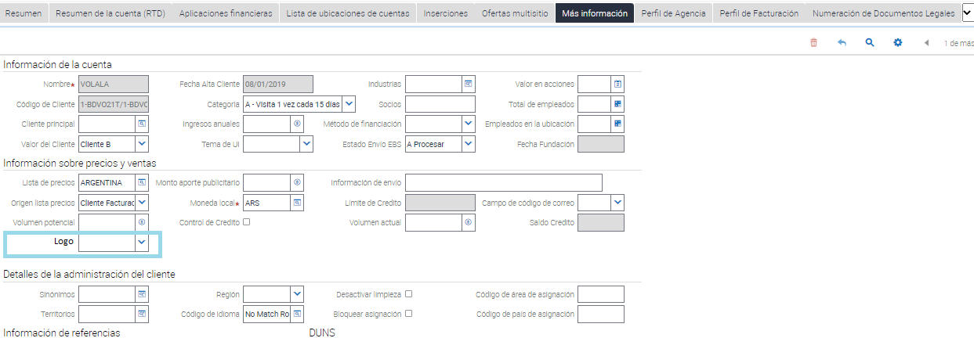

Ruta de los logos cobranding.  
  
<https://universalassistance.sharepoint.com/:f:/s/UA-Aplicaciones/EhvQcZXty_5Jt1ME7bSihDwB3tC94snmyGRGRmbotpnFYw?e=VhgyDD>

Archivo con los nombres de los logos

<https://universalassistance.sharepoint.com/:x:/s/UA-Aplicaciones/EdW0klL6GpBOvFZdb8Cfcs8BWxYj1-VAthv3LtPnQ4mw7Q?e=1TQyq4>

**Bloque servicios**

Estas cajas seran fijas con el texto indicado para cada cuadro.

**Bloque Medios de contacto e Importante**

Este bloque va ser fijo para todos los canales.

**Bloque Cobertura**

Este bloque va a ser el mismo para todos los canales, donde se va agregar el Número de voucher

Tabla de detalle del producto

[Denominacion] = Debera mostrar la denominacion del producto.

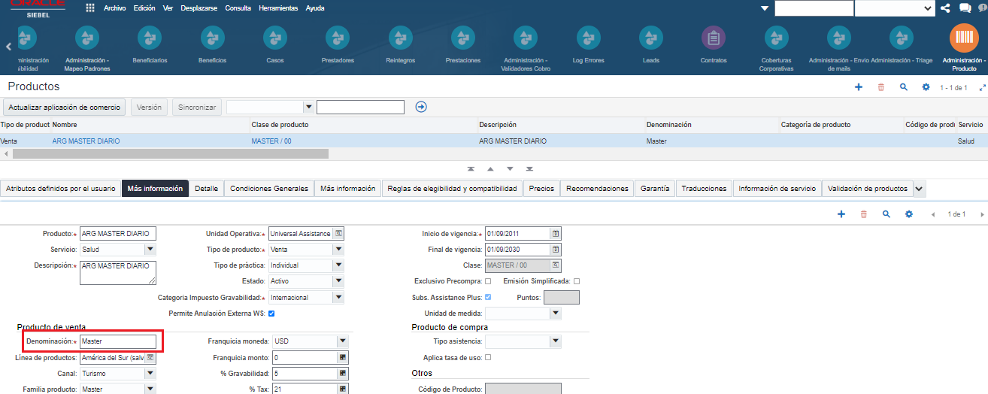

Se deben mostrar de los atributos del producto las siguientes columnas:

* Definición de Atributos
* Unidad de medida
* Limite.

Dentro de los atributos de la cobertura se mantendrá como se despliega actualmente, pero se mostrará la “Definción de Atributos” contratado, en lugar de mostrar la columna “Nombre”.

Se mostrara la “Definición de Atributos” que se muestra en Administracion – Producto – Clase de producto – Workspace - Atributos

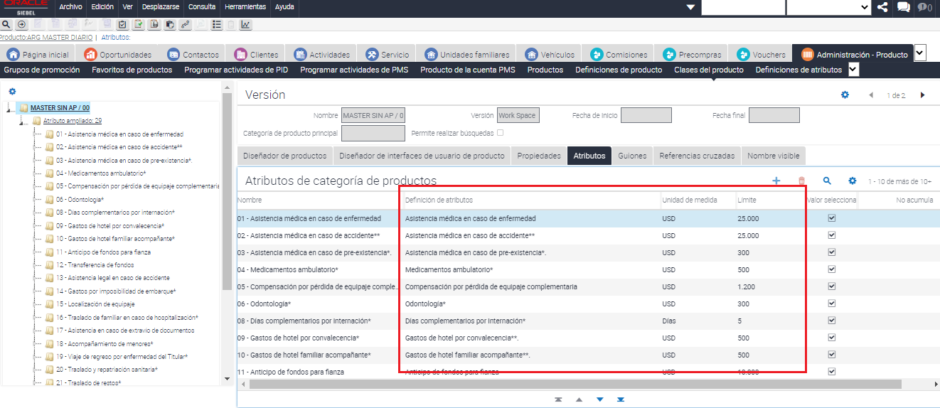

**Bloque: Legales Datos Personales ( por país de la organización emisora del voucher)**

ARGENTINA

COLOMBIA

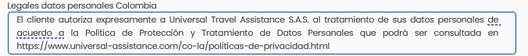

MEXICO

URUGUAY

Genérico para el resto de los países (país de la organización emisora del voucher distinto de ARGENTINA MEXICO COLOMBIA URUGUAY)

**Bloque: Legal por cancelación (genérico para todos los países)**

**Bloque: Legal por tipo de venta del producto + Organización Emisora**

Legal por Tipo de Venta: "Anual con renov. automática", genérica (con organización **DIFERENTE** a "CITI ANUALES" y DIFERENTE a “BBVA DISE”)

Legal por Tipo de Venta: "Anual con renov. automática" con organización **IGUAL** a "CITI ANUALES"

Legal por Tipo de Venta: "Anual con renov. automática" con organización **IGUAL** a "BBVA DISE"

**Bloque Solicitud Asistencia**

Texto fijo genérico

Bloque opcional por organización emisora “Humano Travel Safe Segurnet”

Bloque Fijo líneas telefónicas (para todas las organzaciones emisoras)(Cuando el cliente es “Humano Travel Safe Segurnet” se muestran ambas, exclusivas y genéricas)

**Bloque Reintegros**

Genérico para todos los países

Texto fijo





**Bloque Legales: De Compra**

Texto fijo



**Bloque con Condiciones Grales y Particulares**

Tomar las condiciones generales o particulares que esten cargadas dentro del voucher, como se muestra en la captura de pantalla y agregar el texto que indica si es una condicion general y/o particular

CONDICIONES_GENERALES:

[**https://www.universal-assistance.com/uploads/ccggs/ccggs_retail_la_v25_espaniol_12mar2020.pdf**](http://www.universal-assistance.com/uploads/ccggs/ccggs_retail_la_v25_espaniol_12mar2020.pdf)

CONDICIONES_PARTICULARES:

**https://www.universal-assistance.com/uploads/ccggs/ccgg_RA_v2020.pdf**

*Condiciones particulares solo se agregar si el voucher tiene alguna.

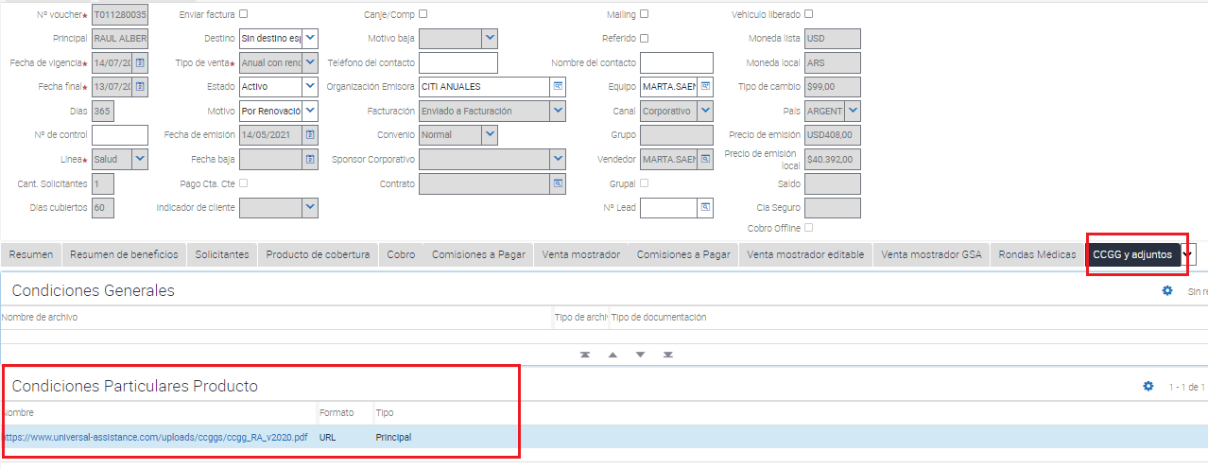

## Mapeo

## Scenarios

1. This section defines the User’s interaction with the system interface, and all other collaborating actors (systems, human, etc.).   
     
   Include references (links) to the all the Use Case Specifications (RA.024) for each use case included in this package.

## Examples

1. If available, you may include examples with actual data to help the reader understand the functionality and flow.

## Business Rules

1. The intent of this section is to consolidate, define, and describe (or reference) the business rules that correspond to the Use Cases contained within this package.   
     
   You may reference specific business rules in the Business Rules Analysis (AN.070), if available.   
     
   Business rules may also be documented in the ***Related Information*** section of the applicable Use Case Specification (RA.024) work products.

## Assumptions

1. The intent of this section is to list any **overall** assumptions for the Use Case Package.
2. The Use Case Specifications (RA.024) may include lower level assumptions. Those do not need to be repeated here.

# User Interface Descriptions

1. The intent of this section is to describe any user interface features – including forms, reports, and user interface storyboard flows – that apply to this Use Case Package.   
     
   It is important not to design the screens and reports but simply to understand the user interface elements that will be required. You should make use of wireframes or prototypes developed in the User Interface Analysis (AN.090) and Conceptual Prototype (IM.005).

## Surface Feature Descriptions

1. List and describe the surface feature elements – form and report wireframes or UI feature lists – that are required to support the Use Case Package.   
     
   Surface Features described in the applicable User Interface Analysis (AN.090) may be referenced or reproduced here. You may also include or reference applicable Conceptual Prototype (IM.005) work product.

## User Interface Flow Descriptions

1. Describe any user interface flows – storyboards – that apply to this Use Case Package.   
     
   You should include or reference all of the applicable user interface flow descriptions (storyboards) documented in the User Interface Analysis (AN.090) and Conceptual Prototype (IM.005) work products.

# Data and Behavior Analysis

1. The intent of this section is to capture all of the data attributes and behavior associated with each of the Use Cases in the Use Case Package. Data can include Entity, attribute, min, max default values and comments, while Behavior can include operations, additional attributes, associations, roles, responsibilities, specializations and generalizations for each Use Case. The standard and recommended approach is to use a UML class diagram to capture and express this information.  
     
   **UML Approach**  
   Because UML Class Diagrams capture both Data and Behavior (operations), you should include or reference the **Analysis Class Diagram** created in AN.050 Analyze Data and AN.060 Analyze Behavior. This diagram will provide Data and Behavior analysis information about the Use Case Package. In this case, you may delete the individual Data and Behavior subsections provided below.  
     
   **Non-UML Approach**  
   If you are not using UML, you may include summary information in this section then use the separate Data and Behavior sections below. For detailed instructions, please see the notes included in those sections and review the Analyze Data (AN.050) and Develop Analysis Specification (AN.100) task guidelines.

## Data Analysis

1. Use this section if you are **not** using a UML class diagram to capture data and behavior for your use case package. Otherwise, this section may be deleted.  
     
   The intent of this section is to capture all of the data attributes associated with each of the Use Cases required by this Use Case Package. Data can include entity, attribute, min, max, default values, and comments. You may simply reference or include the Data Analysis (AN.050) for this package. If not available or if the data requirements are very simple, you may use the table below.

| Entity (Class) | Attribute (Data Field) | Minimum Value | Maximum Value | Default Value | Comments |
| --- | --- | --- | --- | --- | --- |
|  |  |  |  |  |  |
|  |  |  |  |  |  |
|  |  |  |  |  |  |
|  |  |  |  |  |  |
|  |  |  |  |  |  |
|  |  |  |  |  |  |
|  |  |  |  |  |  |
|  |  |  |  |  |  |
|  |  |  |  |  |  |

## Behavior Analysis

1. You should use this section if you are using a non-UML approach and are not employing a UML class diagram to capture data and behavior for your use case package. Otherwise, this section may be deleted.  
     
   The intent of this section is to capture all of the system behavior that is required to support the Use Case Package. This can include operations, additional attributes, associations, roles, responsibilities, specializations and generalizations for each Use Case. You should include or refer to the AN.060 Behavior Analysis when completing this section. You may use a functional decomposition, process mapping, or other notation to express this information.

# Interface Analysis

1. The intent of this section is to describe the all external interfaces from this Use Case Package’s point of view. This includes other use case packages and/or external systems. The intent is to describe the high level exchange of messages and information from the use case package under consideration to any external interfaces. You may refer to or include the Package Diagram and Sequence Diagram from the Architecture Description (RD.130). For simple use case packages, you may use the table below.

The <Use Case Package Name> is dependent on the following components and external systems.

| Use Case Name | External System Name, Component Name, or Service Name | Messages | Frequency | Interface Requirements | Message Parameters (data exchanged) |
| --- | --- | --- | --- | --- | --- |
|  |  |  |  |  |  |
|  |  |  |  |  |  |
|  |  |  |  |  |  |
|  |  |  |  |  |  |
|  |  |  |  |  |  |
|  |  |  |  |  |  |
|  |  |  |  |  |  |
|  |  |  |  |  |  |
|  |  |  |  |  |  |

# Open and Closed Issues

1. Add open issues that you identify while writing or reviewing this document to the open issues section. As you resolve issues, move them to the closed issues section and keep the issue ID the same. Include an explanation of the resolution.  
     
   When this work product is complete, any open issues should be transferred to the project- or process-level Issue Log (Manage focus area) and managed using a project level Issue Form (Manage focus area). In addition, the open items should remain in the open issues section of this work product, but flagged in the resolution column as being transferred.

## Open Issues

| ID | Issue | Resolution | Responsibility | Target Date | Impact Date |
| --- | --- | --- | --- | --- | --- |
|  |  |  |  |  |  |
|  |  |  |  |  |  |
|  |  |  |  |  |  |
|  |  |  |  |  |  |

## Closed Issues

| ID | Issue | Resolution | Responsibility | Target Date | Impact Date |
| --- | --- | --- | --- | --- | --- |
|  |  |  |  |  |  |
|  |  |  |  |  |  |
|  |  |  |  |  |  |
|  |  |  |  |  |  |